OPSC6311 POE
Planning and Design

Group participants:
ST10457568 [TINOTENDA MARUMAHOKO]
ST10454395 [CAMERON REECE JOHANNES]
ST10451742 [WASAMA MAKOLO]
ST10438423[LIAM FRANS]

INTRODUCTION
In today’s fast-moving world, managing personal finances can be difficult and often leads to stress and poor long-term planning. FlowFund is a personal finance app designed to make it easier to track income and expenses using a simple and user-friendly interface. The main goal of this app is to help users take control of their money by providing real-time updates, automatic budget tracking, and clear visual reports. By connecting daily spending with long-term financial goals, FlowFund helps users better understand their finances and supports improved financial knowledge and stability.

APP NAME: FlowFund
ICON DESIGN:
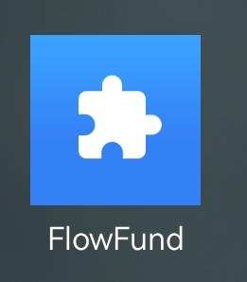

USER INTERFACE DESIGN
The dashboard (overview) gives a quick and clear view of a user’s finances. It shows important information like the total balance, monthly income, and monthly expenses at the top Key features include spending charts, income vs. expense bar graphs, and a “Financial Insights” section at the bottom that provides helpful tips and guidance.

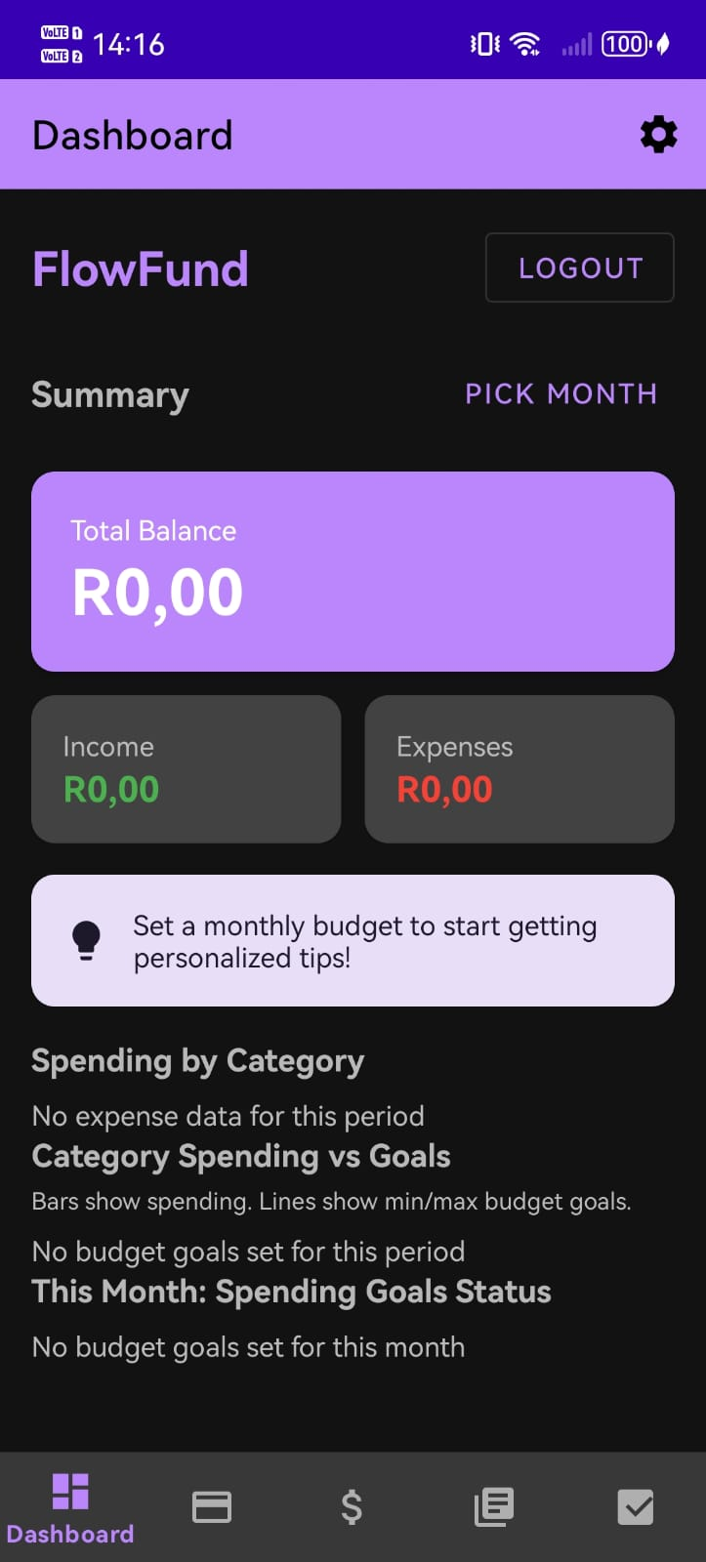
Figure 1:Dashboard

TRANSACTIONS: This section will show a detailed, time-ordered list of all money spent and earned. It includes useful features like a search bar to filter transactions, icons for different categories, and a clear “+ Add Transaction” button to encourage users to add their own records.

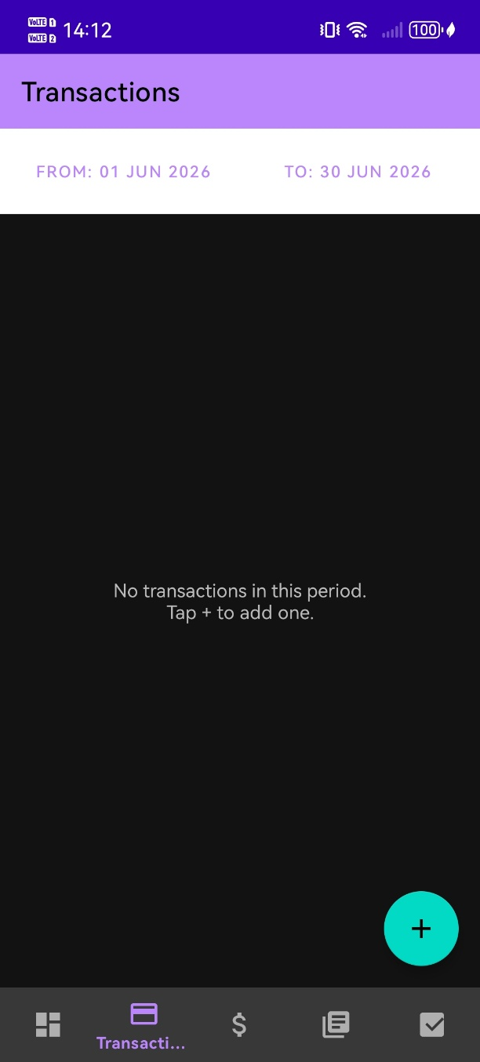

Budget: The Budget Screen allows users to set and manage their monthly spending limits for different expense categories. Users can enter a budget amount and track their progress throughout the month. As users stay within their budget and achieve their financial goals, they earn achievement badges that recognize their progress and encourage responsible spending. These badges provide motivation and help users build better budgeting habits over time.

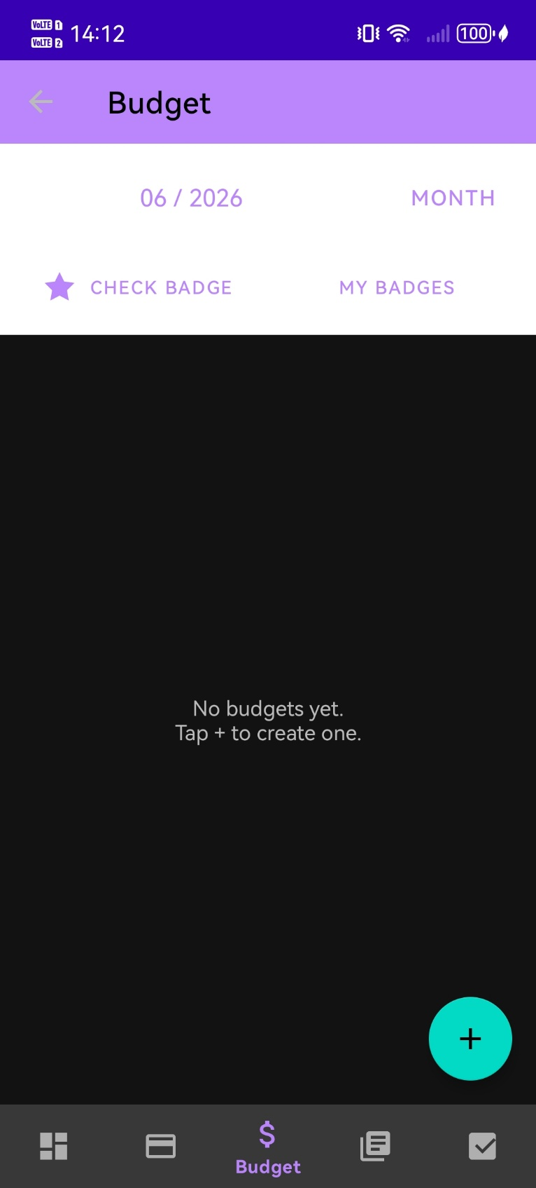
Categories: The Category screen allows users to create and manage expense categories for better financial organization. Users can enter a category name, such as Food, Transport, or Entertainment, and choose a colour to represent it. The selected colours make categories easier to identify and help users track their spending more effectively.
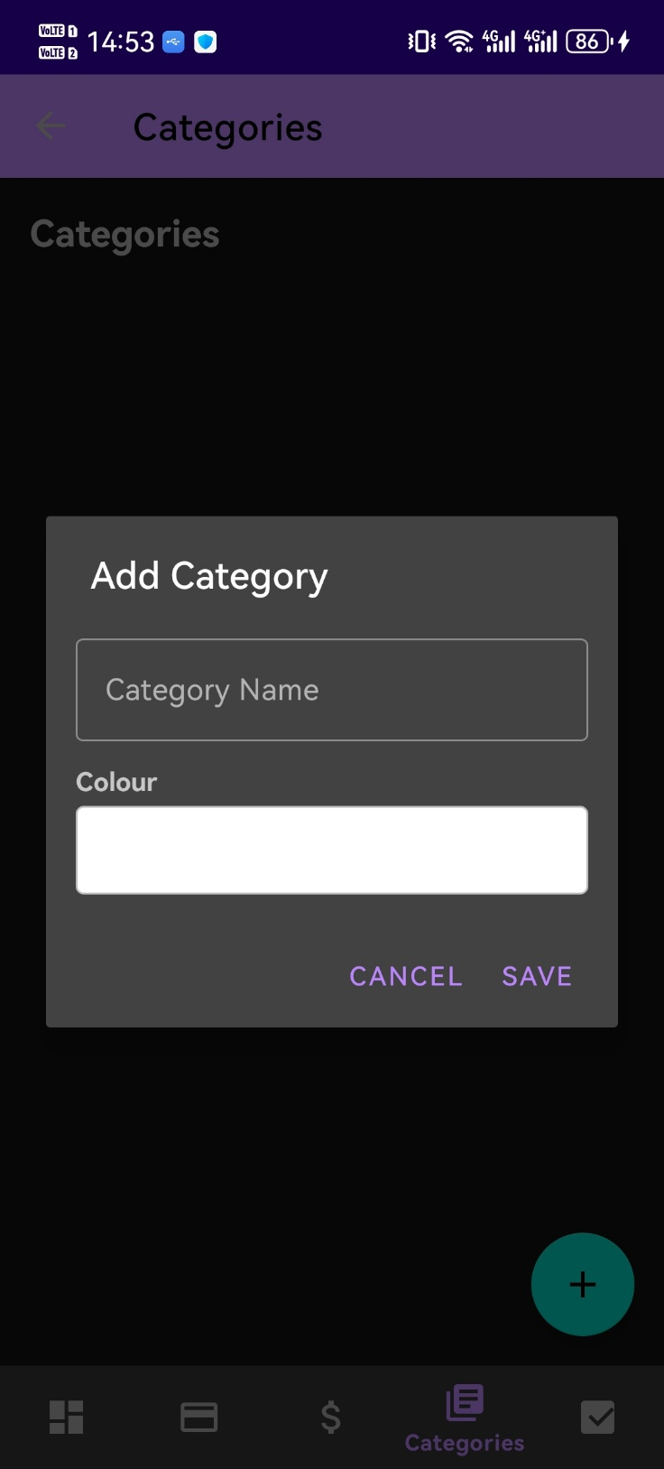

Goals: The Goals Screen allows users to create and manage their financial goals in a simple and organized way. Users can give each goal a name, set a target amount, enter their current savings amount, and choose a deadline for achieving the goal. The screen helps users track their progress over time and stay motivated to reach important financial milestones, such as saving for a vehicle, holiday, emergency fund, or investment.

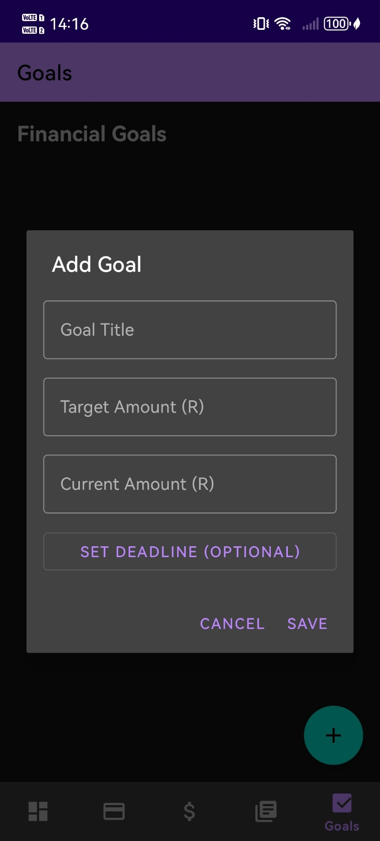

Settings: The Settings Screen allows users to personalize the application according to their preferences. Users can choose between a light or dark theme, select their preferred currency for displaying financial information, and learn how the badge system works. The badge information section explains the requirements for earning badges and helps motivate users to achieve their budgeting and savings goals.

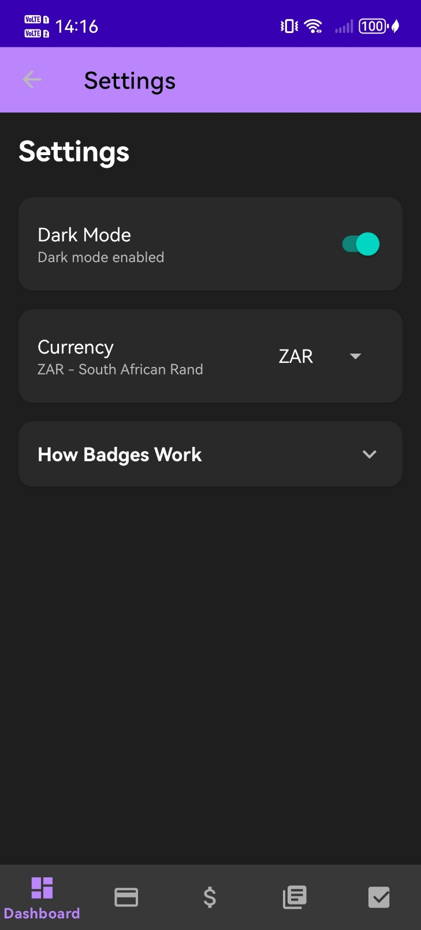

Design
- ACCOUNT AND SECURITY
- The user can register using an email and a password.
- The user should be able to log in and log out.
- Password encryption to protect the user's information.
- An option for the user to be able to reset their password if they forget.
- Financial information should be stored securely for privacy and protection.

- INCOME AND EXPENSE TRACKING
- Users must be able to add income.
- Users must be able to add expenses.
- Transactions should include Amount, Category, Date, and an optional description.
- Must be able to edit or delete transactions.

This requirement is based on Mint’s strength in automated tracking and Wallet’s flexibility for manual transaction recording.

- CATEGORY BUDGETING
- The users must be able to create budget categories (Eg, Food and Transport)
- The user should have the ability to attach a photo (Eg, a receipt) to each entry.
- Set spending limits for each category.
- The app should display how much money is spent or remaining.
- The app should provide alerts for when users are close to exceeding their budget.
- The App should support a monthly budgeting system.

- FINANCIAL REPORTS AND DATA
- The app must create charts and graphs.
- Users must be able to view their daily, weekly, and monthly summaries.
- Receipts within that period should be displayed and accessible.
- Display total amount spent on each category.
- The app should have a dashboard that displays Total Balance, Total Income, and Total Expenses.
- Graphs should be able to show category spending.
- Easy to understand and visually clear.

This requirement is based on Wallet’s financial reporting system and Mint’s spending trend analysis, which help users understand their financial behaviour.

- GOAL TRACKING
- The ability to create financial goals (Eg, saving money or paying off debt).
- Goals should include target amount and deadlines (optional).
- Visual indicators for goals.
- Motivation Feedback when progress is made.

- ALERTS AND NOTIFICATIONS
Notifications for:
- Budget Limits being reached.
- Upcoming expenses and bills.
- Adding transactions.
- Reviewing budgets.

This requirement is based on Mint’s alert system, which helps users stay aware of their financial situation.

- SHARED BUDGETING
- The ability to share budgets with others.

- USER INTERFACE

- Android studio will be used as the platform to build the App
- Kotlin will be used as the programming language
- Simple and clean.
- Navigation must be clear and intuitive.
- Important information to be displayed on the main page.
- Work smoothly on android devices
Include:
    - Icons.
    - Colors.
    - Visual indicators (Eg, progress bars and graphs).

- GAMIFICATION AND INNOVATION
- Users earn badges for staying within budget.
- The app provides simple financial advice.
- Dark Theme Mode to improve usability at night.
- Inbuilt currency conversion.

These requirements ensure that Flow Fund is a complete and functional budgeting application. The features combine automation (like Mint), structured budgeting (like YNAB), and strong reporting tools (like Wallet), while also introducing new features.
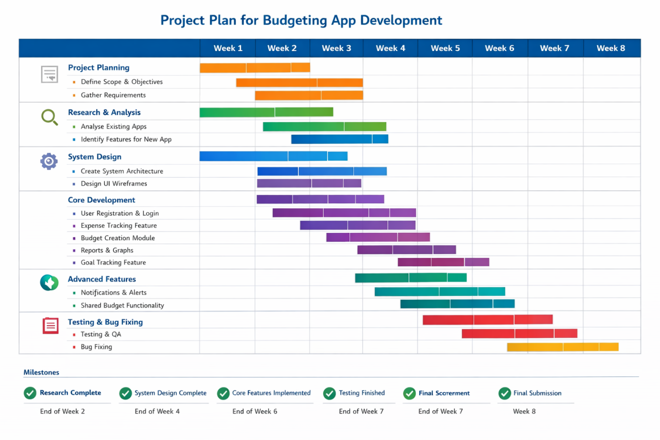

Project Plan
The project will be completed over a period of eight weeks by a team of four participants. Each milestone will be assigned to two team members who will work together to complete the required tasks before moving on to the next phase.
During Project Planning, the assigned participants will define the project scope, objectives, and requirements. In Research and Analysis, two participants will analyse existing budgeting applications and identify useful features for the proposed system. For System Design, team members will create the system architecture, database structure, and user interface designs.
The Core Development milestone will involve implementing the main features of the application, including user registration, expense tracking, budgeting, reporting, and goal tracking. During Advanced Features, two participants will develop additional functionality such as notifications, alerts, and shared budgeting features. Finally, in Testing and Bug Fixing, the assigned team members will test the application, identify issues, and resolve bugs to ensure the system is fully functional before final submission.
Regular communication between all four participants will ensure that progress is monitored and that each milestone is completed on schedule.

References
Google (2026) Android Studio. Available at: https://developer.android.com/studio (Accessed: 10 May 2026).
Intuit (2026) Mint – Personal Finance & Budgeting App. Available at: https://mint.intuit.com (Accessed: 4 May 2026).
Investopedia (2026) Personal Finance and Budgeting Resources. Available at: https://www.investopedia.com/personal-finance-4427760 (Accessed: 18 May 2026).
Microsoft Corporation (2026) Microsoft Word. Available at: https://www.microsoft.com/microsoft-365/word (Accessed: 21 May 2026).
NerdWallet (2026) Budgeting and Financial Planning Tools. Available at: https://www.nerdwallet.com (Accessed: 5 May 2026).
Wallet by BudgetBakers (2026) Personal Finance Manager App. Available at: https://budgetbakers.com/wallet (Accessed: 10 March 2026).
You Need A Budget (YNAB) (2026) Budgeting Software for Financial Control. Available at: https://www.ynab.com (Accessed: 1 June 2026).

